Andre Hardy – Project 6-4

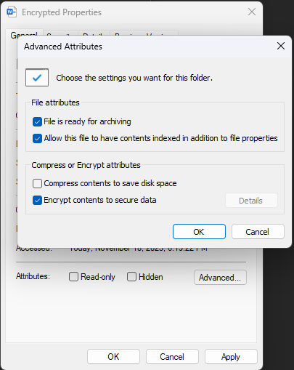

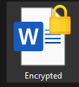
11. Launch Microsoft Word and then open encrypted.docx. Was there any delay in the operation?
A: There was no noticeable delay when opening the file
12. now open Not encrypted.docx. Was it any faster or slower?
A: There was no noticeable difference in speed of opening the two files.

